Wordly Website Instructions
Instructions

Use this template to add clear instructions to your website on how attendees can access live translation and captions at your meetings and events.

Template

To access live translation and captions and meetings and events, follow the steps below:

- Scan the QR code or visit the following link: attend.wordly.ai/join/XXXX-XXXX
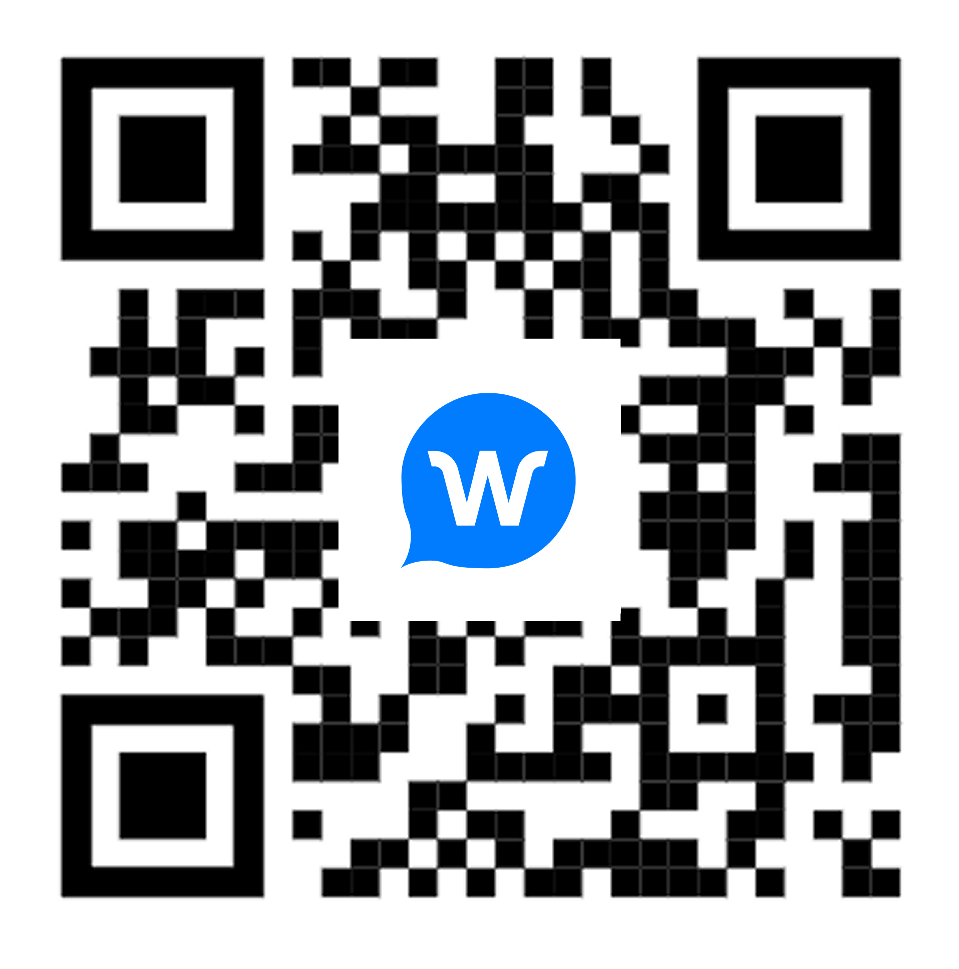
SAMPLE
- Select your preferred language from the dropdown menu under “Choose Language”
- Select “Attend”
- Read the live text transcript in the language you selected
- To listen to audio, plug in your headset and turn on the audio button. Make sure your phone is NOT set to silent.

[Customer Name] is proud to offer live AI translation and captions powered by Wordly—making our meetings and events more inclusive, accessible, and engaging.

No app download or account creation is required to participate.

